**CREATING MICROSERVICES FOR ACCOUNT AND LOAN.  
ACCOUNT**

package com.cognizant.account.controller;

import org.springframework.web.bind.annotation.GetMapping;

import org.springframework.web.bind.annotation.PathVariable;

import org.springframework.web.bind.annotation.RestController;

import java.util.Map;

@RestController

public class AccountController {

@GetMapping("/accounts/{number}")

public Map<String, Object> getAccountDetails(@PathVariable String number) {

return Map.of(

"number", number,

"type", "savings",

"balance", 234343

     );

    }

}

package com.cognizant.account;

import org.springframework.boot.SpringApplication;

import org.springframework.boot.autoconfigure.SpringBootApplication;

@SpringBootApplication

public class AccountApplication {

public static void main(String[] args) {

SpringApplication.run(AccountApplication.class, args);

}

}

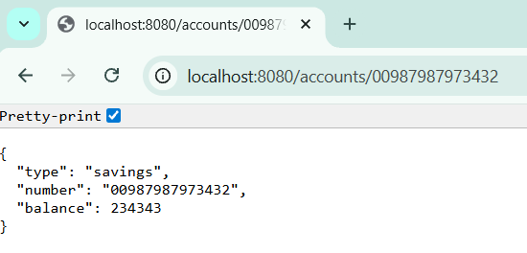

**LOAN**

package com.cognizant.loan.controller;

import org.springframework.web.bind.annotation.GetMapping;

import org.springframework.web.bind.annotation.PathVariable;

import org.springframework.web.bind.annotation.RestController;

import java.util.Map;

@RestController

public class LoanController {

@GetMapping("/loans/{number}")

public Map<String, Object> getLoanDetails(@PathVariable String number) {

return Map.*of*(

"number", number,

"type", "car",

"loan", 400000,

"emi", 3258,

"tenure", 18

);

}

}

package com.cognizant.loan;

import org.springframework.boot.SpringApplication;

import org.springframework.boot.autoconfigure.SpringBootApplication;

@SpringBootApplication

public class LoanApplication {

public static void main(String[] args) {

SpringApplication.run(LoanApplication.class, args);

}

}  
  
spring.application.name=loan

server.port=8081

